**Instructor Signature: ________________________**

**Date: 1/30/2021**

Introduction: There are several benefits for being familiar with the terminal command line prompt and the Linux operating system; the ability to access the configuration tool through remote access to controlling files, folders, and writing code. We will be using the RPi raspi-config option to adjust the configuration settings on the RPi and an introduction to using the terminal with basic Linux commands to explore files, folders, and additional resources that the RPi. We will also use GitHub and Raspberry Pi Foundation site to add applications to your Pi.

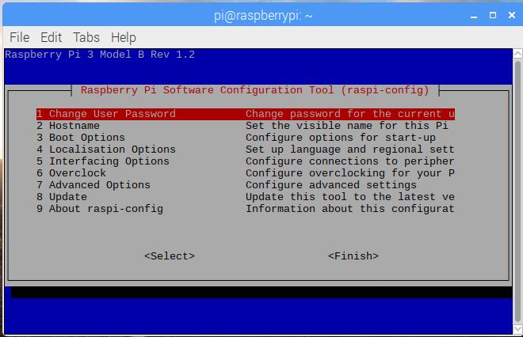

One of the coolest things about working with the RPi is that it is an open source platform and there is so many “official and unofficial” sources for applications, projects, and individuals who have done so much with this system. The RPi is a wonderful platform to play with because it supports multiple operation systems, can be programmed in a wide variety of languages, and gives you the flexibility of a small microcontroller to access the general purpose input/output pins to control hardware. If you have children and/or nephews & nieces it is a really nice platform to explore programming and embedded projects with them.

The raspberry pi is a wonderful unit to start learning the Unix/Linux based operating system. Many of the commands and options are the same as using Mint, Ubuntu, etc. which are versions of distributions or distros.

Here is a list of resources and websites that we will start to explore with this lab:

1. Linux and the Pi is: <http://elinux.org/> for both hardware and software references.
2. Raspberry Pi Foundation is: <https://www.raspberrypi.org/> (the mothership)
3. MagPi Magazine is: <https://www.raspberrypi.org/magpi/>
4. PiHut Store is: <https://thepihut.com/>
5. GitHub for RPi is: <https://github.com/raspberrypilearning>

**Outcomes:**

**As a result of this activity you will be able to –**

1. Have a working knowledge of basic Linux commands.
2. Demonstrate adding and deleting users and permissions for resources on the Pi (i.e., sudo, gpio, etc.)
3. Changing password and hostname of the Raspberry Pi.
4. Demonstrate changing resource access with raspi-config environment.

**Equipment and Supplies:**

Raspberry Pi Unit

PC with Internet Access for Remote Connection

Procedure I: Basic Linux Commands Explored

You have already been introduced to apt-get upgrade, apt-get update, and apt-get install that installs new applications and update the Raspbian Kernel. There are some foundation commands that are very useful and are listed in Table 1: Linux Command Line Basics.

1. Open the Terminal and type at the prompt **$** type ***ls***
   1. What are your observations in the terminal?
      1. Looks like it is showing me all the folders I have on my Pi.
2. To make a new directory type at the prompt ***mkdir MyFolder*** Where MyFolder in the name of the new folder.
   1. What are your observations in the terminal?
      1. There is no indication that anything happened other than the lack of an error message I entered the ls command again and now can see my folder in the list.

Note: There should be no spaces in folder or file names. The “tab” key is used to auto complete the command.

1. To change your location to the new folder type at the prompt ***cd MyFolder***
   1. What are your observations after typing at the prompt ***ls***
      1. Nothing comes up which I believe indicates that my folder is empty
   2. Is the folder empty? YES / NO
2. 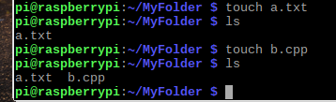To add a new file we will use the touch command which is one of the easiest ways to create an empty new file. Type at the prompt ***touch a.txt*** Then type ***touch b.cpp***
3. Do not close the terminal but use your mouse to click on the folder view on the Ribbon of the Desktop and find your MyFolder with the two files in it. Do you see all of the items including the folder you created? YES / NO

Note: The touch command requires you to type in the file extension type when you type the name of the file to generate a new file otherwise it will create a generic text file.

1. Type at the prompt ***ls***
   1. What are your observations
      1. It lists the 2 files I just created
2. Type at the prompt ***ls –l***
   1. What are your observations
      1. It shows me the files I made and what I assume is the time they were created or last changed with the permissions of the file.



Notice the addition of –l gives you a list of permissions on each file within the folder. In another lab we will look at changing permissions and the type of file that it is (i.e., read, write, executable or super special).

Nomenclature for what type of permissions the file has with the current user.

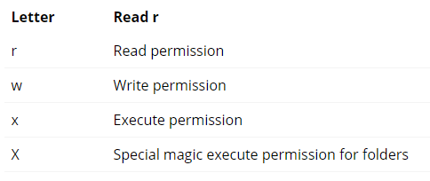

Using the ls command with –l on the directories gives you additional information about the directories on the Pi

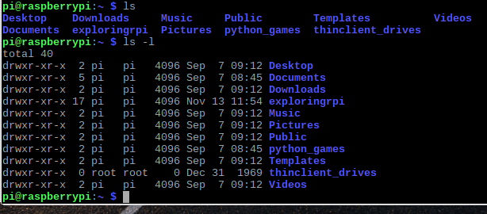

Let’s continue playing in the terminal

1. Type at the prompt ***man ls***
   1. What are your observations
      1. It gives you all the information of the ls command.
2. Type at the prompt ***rm b.cpp*** and then ***ls***
   1. What are your observations
      1. It looks like it removed my b.cpp file.
3. Type at the prompt ***ls*** and then ***pwd***
   1. What are your observations
      1. It said it cannot access pwd no such file or directory.
4. Type at the ***prompt rmdir MyFolder*** then type ***ls***
   1. What are your observations and what do you think is the problem?
      1. I cannot remove the directory because I am currently accessing it.
5. Type at the ***prompt cd*** then type ***ls***
   1. What are your observations
      1. I am back to the initial point and can see all my folders/directories.
6. Type at the ***prompt rmdir MyFolder*** then type ***ls***
   1. What are your observations and what do you think is the problem?
      1. It says it cannot remove the directory because it is not empty so I need to empty it first.

There are two options to remove the directory with or without files in it:

* + 1. Change the directory back to MyFolder directory and remove all of the files using the rm command (remember to also type the name of the file). Then change the directory back to Home/pi/ by typing cd at the prompt.
    2. Using the ***rmdir*** command. Create a folder with a file in it. Then use this command to delete it.

Use the Folder View on the Ribbon on the Desktop to verify what the list command shows. Then return to the terminal for a couple of more commands before moving on.

1. Type at the prompt ***whoami***
   1. What are your observations
      1. It said pi since I am logged in under that username.
2. Type at the prompt ***hostname***
   1. What are your observations
      1. It responded raspberrypi.
3. Type at the prompt ***history***
   1. What are your observations
      1. Showed me a list of the commands I have put into the Terminal throughout all my sessions.

*By typing history this will list all previous commands that you have typed. You can also use CTL-R to get an interactive search and find a recent command. Press “Enter” activates the command. Pressing “Tab” places you on the command line so that it can be modified. Try it out!*

1. In the lab synopsis generate Table 1 and fill-in what the commands do and major options (i.e. ls is list command for showing files and directories). The –l used with list gives you a listing of permissions, sizes of files and directories and users associated with the items. Use the man command, Internet Research, and textbook to see other major options.

Table 1: Linux Command Line Basics.

|  |  |  |
| --- | --- | --- |
| **Command** | **What does it do?** | **Major Options with Command** |
| ls | Lists files or directories | -l, -a, -lh, -F, -r, -R, -ltr |
| cd | Change directory | -, .., --, ../ ../ |
| pwd | Tells you where you are in which directory | -L, -P, |
| rm | Deletes files | -f, --help, --version, -i, -I |
| rmdir | Remove directories | -help, -p, -v, -version |
| mkdir | Make new directory | -p, -R, -m777 |
| man | Display user manual | -f, -f ls, -a, -k |
| touch | Create or change files | -a, -c |
| history | Show the history of Terminal commands | -c, -n, -r, -w |
| whoami | Display current user | -help, --version |
| hostname | Obtain DNS and set hostname | -i, -I, -d, -f, -A |

Procedure II: Creating and Deleting Users, Groups, and Changing Passwords on your Pi

By default the RPi comes with two users “pi” and “root”. The root user has more privileges as a super-user but it also comes with the risk of inadvertently corrupting the operating system. The best option is to set up a new user with a unique password that you can log into.

1. At the command prompt type ***more /etc/group***
   1. What are your observations?
      1. It gave me a list what seems like directories
2. At the command prompt type ***groups***
   1. What are your observations?
      1. It gave me a list of groups on the system.

Notice with the two prior commands you can see all of the users and groups that are on the Pi and what privileges that they have on the Pi include the root user.

Let’s start adding users and give them privileges on the Pi. In this section if you see values inside braces [ ] this means that you need to type in a name without braces for a user account. The video for adding and subtracting users will be invaluable for this section to watch.

1. At the prompt type ***sudo adduser [name for account]***
2. You will be prompted to type in a password for the new user. Type something easy to remember (we will be deleting this user at the end). Optional information after the password is updated such as Full Name, Home Room, etc., does not need to be filled and just press enter for each item until you see the prompt again.
   1. Type ***groups [name for account]*** and does the user have any priviledges? Just chris.
   2. Type ***groups pi*** and compare the privileges between the two user accounts. Pi has privileges for 16 different things.
3. Let’s add two privileges to your user account. At the prompt type ***sudo adduser [name for account] sudo*** This will add the ability of sudo to the user account. Add a second privilege to the account before moving on to the next step.
4. To delete privileges for a user type at the prompt ***sudo deluser [name of account] sudo***
5. Before deleting the user completely let’s do two things. Without closing the terminal session use the file folder tool on the main menu of the desktop and click and open it to see the new folder profile of the user. How is it labeled? For example the default Pi user’s folder profile looks like this: /home/pi
   1. It is labeled as /home/chris
6. Last item before we delete the user what happens if you forget the password for the user? No worries it is real easy to deal with for the new user and/or the Pi user. At the prompt type ***sudo passwd [name of account]*** There will be a prompt for a new password.
   1. If you type ***sudo passwd*** with no user name then you are changing the password for ‘pi’. Change your password and write it down somewhere so you can remember it.
7. To completely delete the user at the prompt type ***sudo deluser [name of account]***
8. Type ***groups [name on account]*** Does the account exist? Use the folder icon in the desktop and see if there are folders for the account? The folder does not exist.

We will work on other Linux commands tied to permissions and changing file modes in a later lab.

Procedure III: Changing the Hostname

The public name that your Pi is known by is called the hostname. When working the Pi in a public setting or if you have multiple Pi units having unique names for them makes it easier to find them on the network. Otherwise you must track them by their MAC address. There are several ways to change the hostname on your Pi. The default hostname is **raspberrypi** with the default user and group **pi** 

1. Preference menu on the desktop for the Raspi-Configure Menu. This must be done with the Pi connected to a monitor, keyboard, and mouse. You cannot access this menu in remote sessions.



1. Raspi-Configuration Menu within the terminal. This can be done either with the Pi connected to a monitor, keyboard, and mouse or within a remote session.

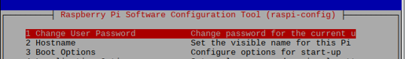

1. Within the terminal session and using the text editor GNU Nano to modify two files that have the hostname in it. This can be done either with the Pi connected to a monitor, keyboard, and mouse or within a remote session. These two file names are:
   1. /etc/hostname
   2. /etc/hosts
2. Regardless of the method used to change the hostname the Pi must be rebooted for the changes to take effect.

In this procedure I will describe how to use the GNU Nano process to modify the two files. In procedure IV you will see the use of Raspi-Config in a Terminal session to modify the Pi unit including the hostname.

1. Open a terminal session on the Pi unit.
2. At the prompt type ***sudo nano /etc/hostname*** and ***press enter***.
3. The hostname is the only text in this file. Change the hostname to something that makes sense to you and keep it PC.
4. To save the changes use ***CTL-O*** to overwrite the changes on the file.
5. To exit Nano use ***CTL-X*** to exit.
6. Keep the terminal session open.

There is a secondary file that other applications use to find your hostname that we need to change.

1. At the prompt type ***sudo nano /etc/hosts*** and ***press enter***.
2. Use the arrow keys on the PC to move down to the line 127.0.0.1 and change the default hostname to your new hostname (yes they need to be the same in both files).
3. To save the changes use ***CTL-O*** to overwrite the changes on the file.
4. To exit Nano use ***CTL-X*** to exit.
5. Type at the prompt ***sudo poweroff*** and ***press enter***.
6. This will terminate the remote session on the PC
7. Allow the Pi to shut down completely before powering it back on so the changes to the hostname will take effect.
8. Find your Pi on the network and log back into it to finish this last part of the lab.

Procedure IV: Using Raspi-Config in Terminal Session

There are times where you will need to get into the configuration menu and the fastest way in remote sessions on the PC is to use the terminal session and the command ***sudo raspi-config***. Typical items to change are hostname, password, forcing the audio out to a 3.5mm jack (PC speakers) instead of the HDMI, or disabling or enabling the peripheral resources such as camera, SSH, GPIOs, etc.

These example menu items below illustrate the use of raspi-config to make changes to the Pi unit. After changes are made there will be a prompt to ask you if you want to reboot the system. Select Yes and allow the Pi unit to reboot before logging back into it.

Under the 7th option (Advanced) is where you can select to find A4 the option for audio.



Select audio and you will be given three options. By default option 0 is okay with Auto. Use the right arrow key to move down to exit out of this menu.

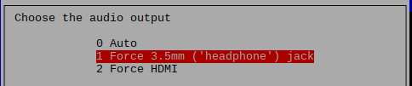

Under the 2nd option (Hostname) this is where you can also alter the hostname. This is the same as editing the name in GNU Nano.

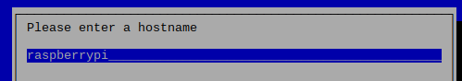

1. Exit out of the hostname option and enter into the interface option (5th).
2. If you have any interface options disabled then change them to enable.

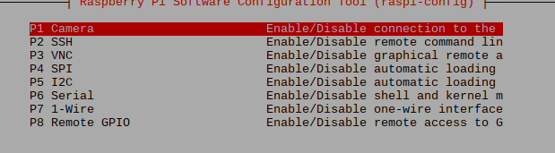

1. Exit Raspi-Config and Reboot the System.
2. If you have not already downloaded the resources for the textbook use the terminal session to download the materials. Verify the download by using the Folder View icon in the Desktop to see the exploringrpi folder.
   1. ***git clone https://github.com/derekmolloy/exploringrpi.git***

Questions for Lab Synopsis:

1. Document your observations from each section including developing Table 1 information.
2. Describe the basic concept of an embedded Linux system.
3. Describe how an embedded Linux device, such as the RPi, boots the Linux OS.
4. What questions do you still have with respect to this lab?
5. What ah-ha moments did you have with this lab?

Please make sure to respond to question 4 and 5 with something substantial.